WEB PHISHING DETECTI0N

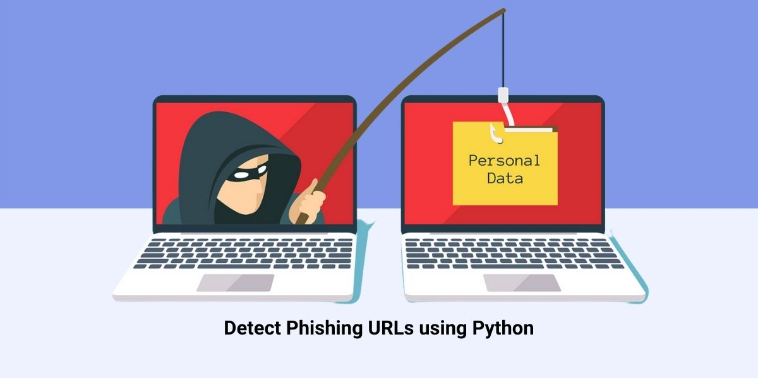

**Proposed Solution**

***TEAM DETAILS***

*TEAM NUMBER : PNT2022TMID34399*

*COLLEGE NAME : CAPE INSTITUTE OF TECHNOLOGY*

*DEPARTMENT : INFORMATION TECHNOLOGY*

**PROBLEM MEMBERS**

* ISWARYA.A
* PARVATHY.T
* SALINI.T
* SAHAYA ABISHA.A



**Proposed Solution**

Project team shall fill the following information in proposed solution template

|  |  |  |
| --- | --- | --- |
| S.No. | Parameter | Description |
| 1 | Problem Statement (Problem to be solved) | Web phishing tends to steal a lots of information from the user during online transaction like username, password, important documents that has been attached to that websites. There are Multiple Types of Attacks happens here every day, but there is no auto detection Process through Machine learning is achieved. |
| 2 | Idea / Solution description | Through ML and data mining techniques like classification algorithm user can able to attain a warning signal to notify these phishing websites which helps the user to safeguard their identities and their login credentials etc. python is the language that helps to enable these techniques for the online users. |
| 3 | Novelty / Uniqueness | This project not only able to identify the malicious websites it also has the ability to automatically block these kind of websites completely in the future when it has been identified and also blocks some various mails /ads from these malicious websites. |
| 4 | Social Impact / Customer Satisfaction | This web phishing detection project attains the customer satisfaction by discarding various kinds of malicious websites to protect their privacy. This project is not only capable of using by an single individual ,a large social community and a organisation can use this web phishing detection to protect their privacy. This project helps to block various malicious websites simultaneously. |
| 5 | Business Model (Revenue Model) | This developed model can be used as an enterprise applications by organisations which handles sensitive information and also can be sold to government agencies to prevent the loss of potential important data. |
| 6 | Scalability of the Solution | This project’s performance rate will be high and it also provide many capabilities to the user without reducing its efficieny to detect the malicious websites. thus scalability of this project will be high. |

